EXP 3: . Create a simple cloud software application for Property Buying & Rental process (In Chennai city) using any Cloud Service Provider to demonstrate SaaS.
DATE:27-02-26
AIM: The aim of the Property Buying & Rental System is to provide a cloud-based platform for users to easily search, buy, and rent properties in Chennai. It simplifies property management for owners and agents while ensuring real-time updates and accessibility.
PROCEDURE:
STEP1:GO TO ZOHOCREATOR.COM AND LOGIN TO YOUR ACCOUNT
STEP2:CLICK CREATE NEW APPLICATION AND CREATE FROM SCRATCH
STEP3: ENTER APPLICATION NAME AND CREATE APPLICATION
STEP4:CLICK ON CREATE NEW FORM AND NAME THE FORM
STEP5:ENTER THE DETAILS
STEP6:THE SOFTWARE HAS BEEN CREATED.

STEP1:GO TO ZOHOCREATOR.COM AND LOGIN TO YOUR ACCOUNT

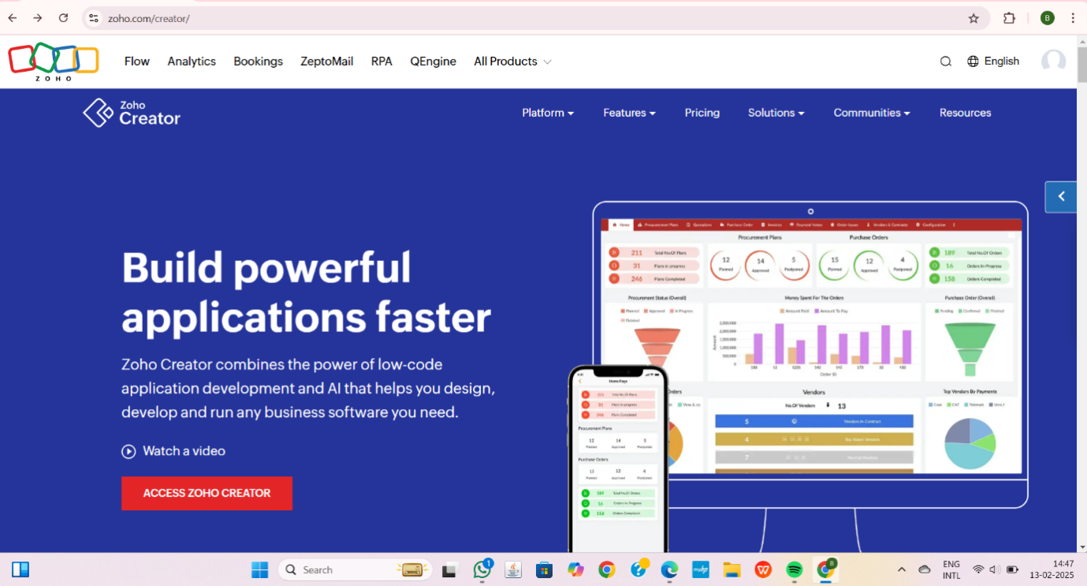

STEP2:CLICK CREATE NEW APPLICATION AND CREATE FROM SCRATCH
STEP3: ENTER APPLICATION NAME AND CREATE APPLICATION

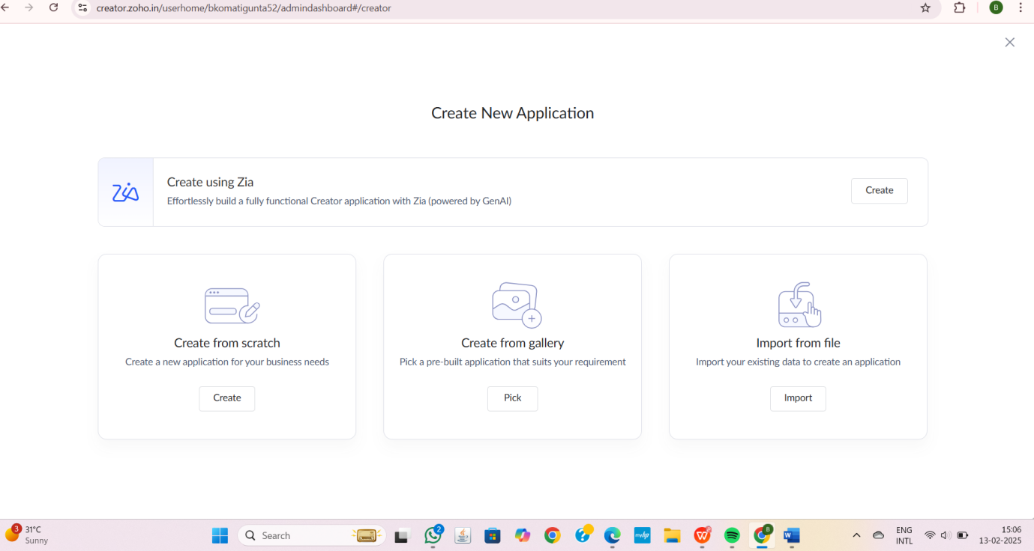

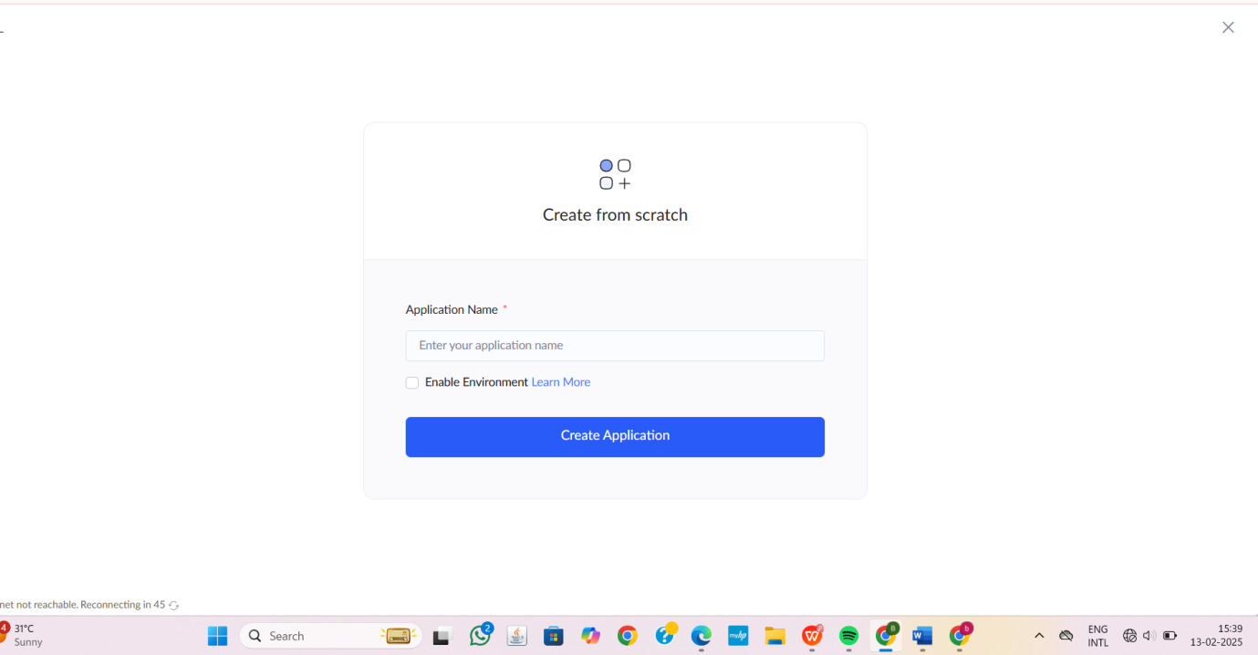

STEP4:CLICK ON CREATE NEW FORM AND NAME THE FORM

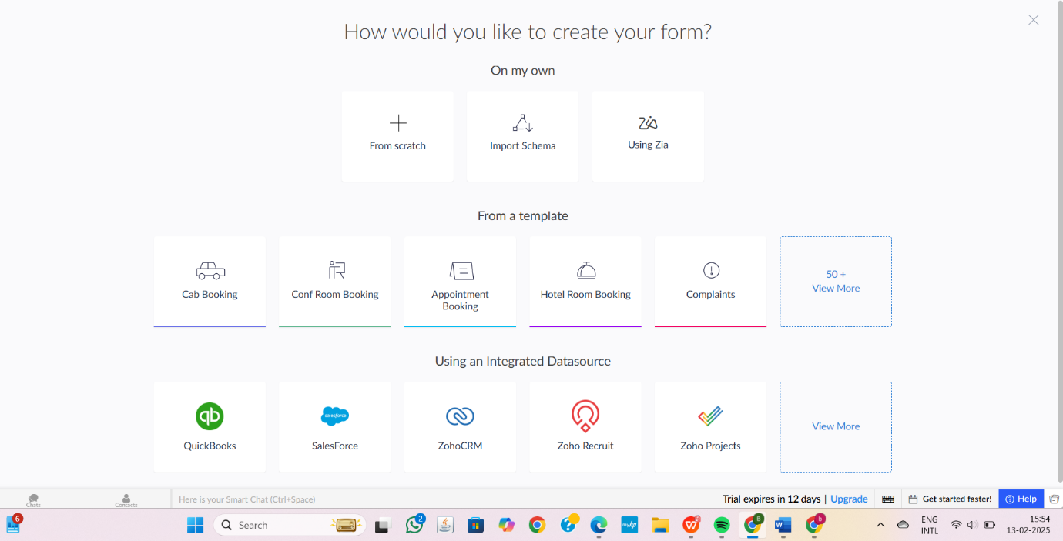

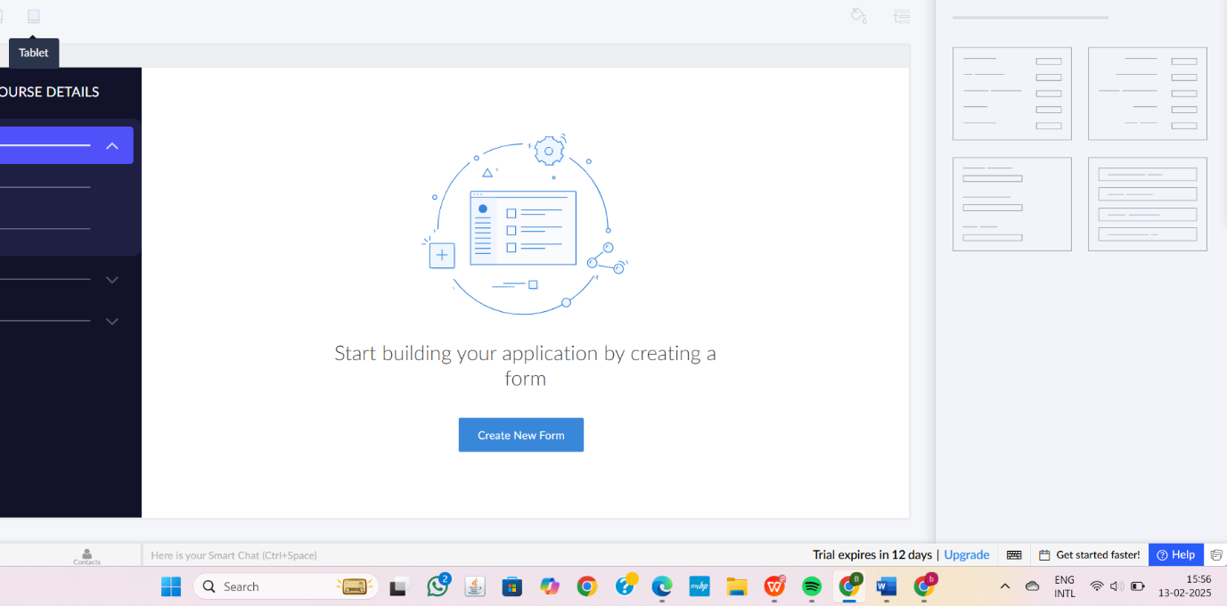

1.PROPERTY INFORMATION AND ITS DETAILS
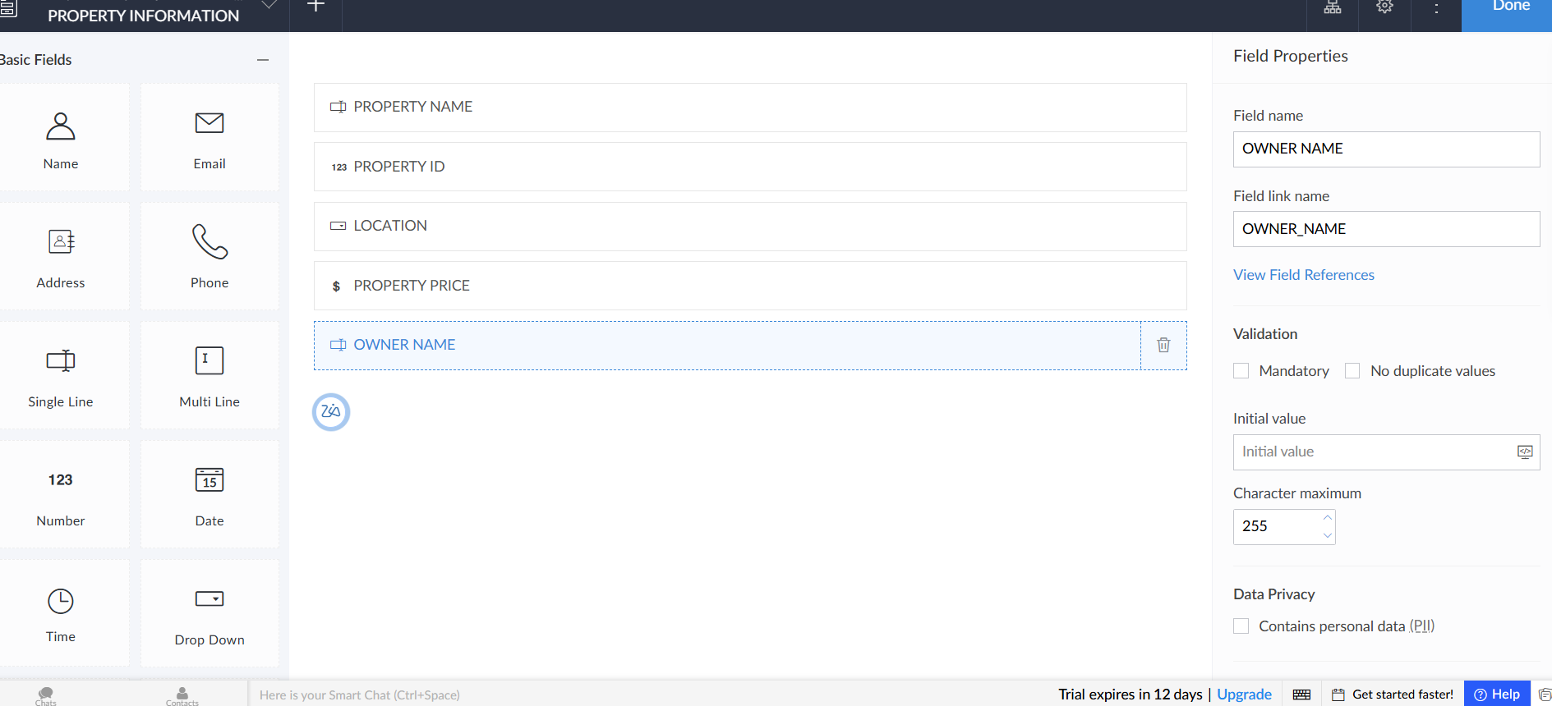

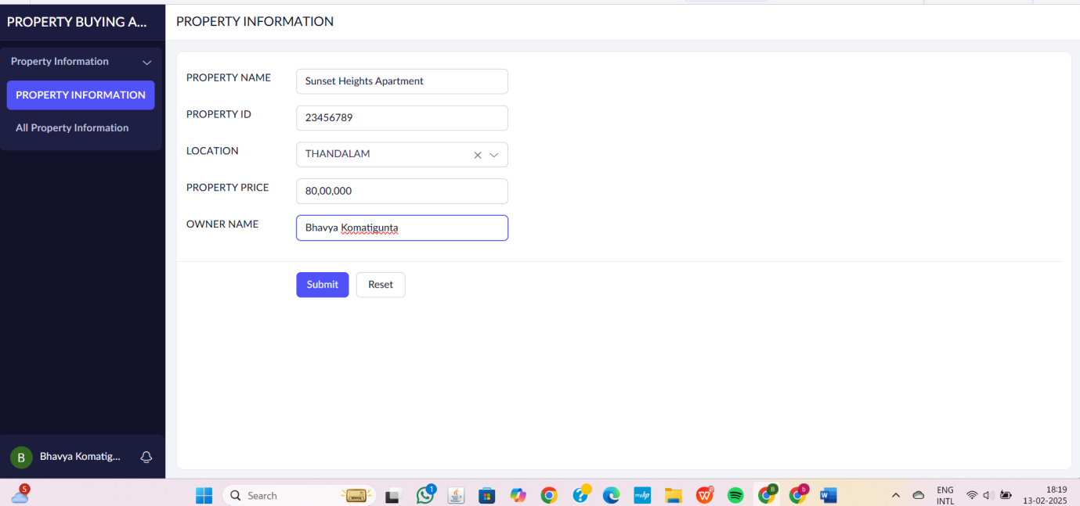

2.USER DETAILS
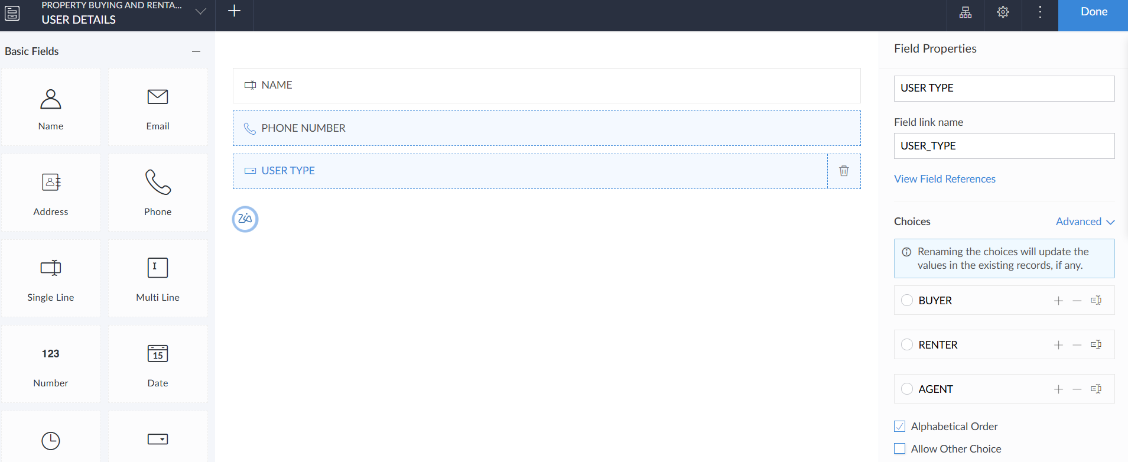

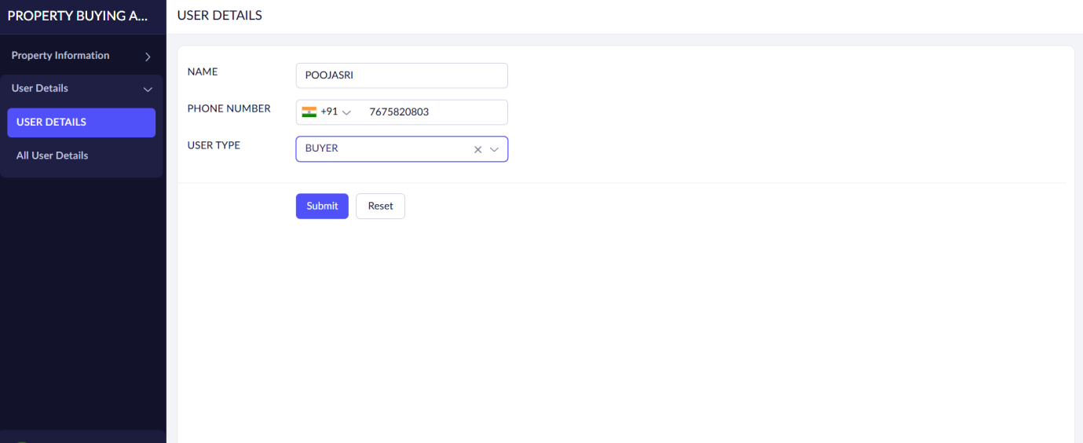

3.TRANSACTION DETAILS

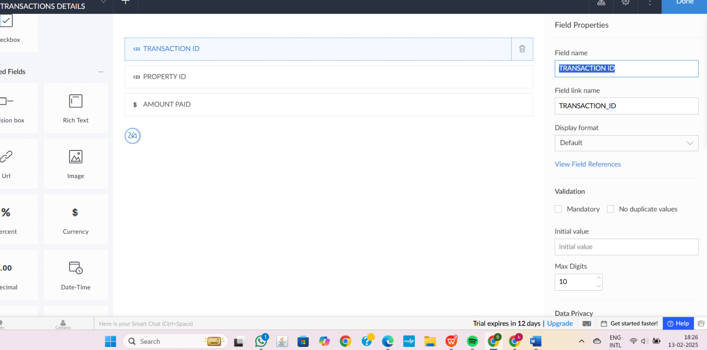

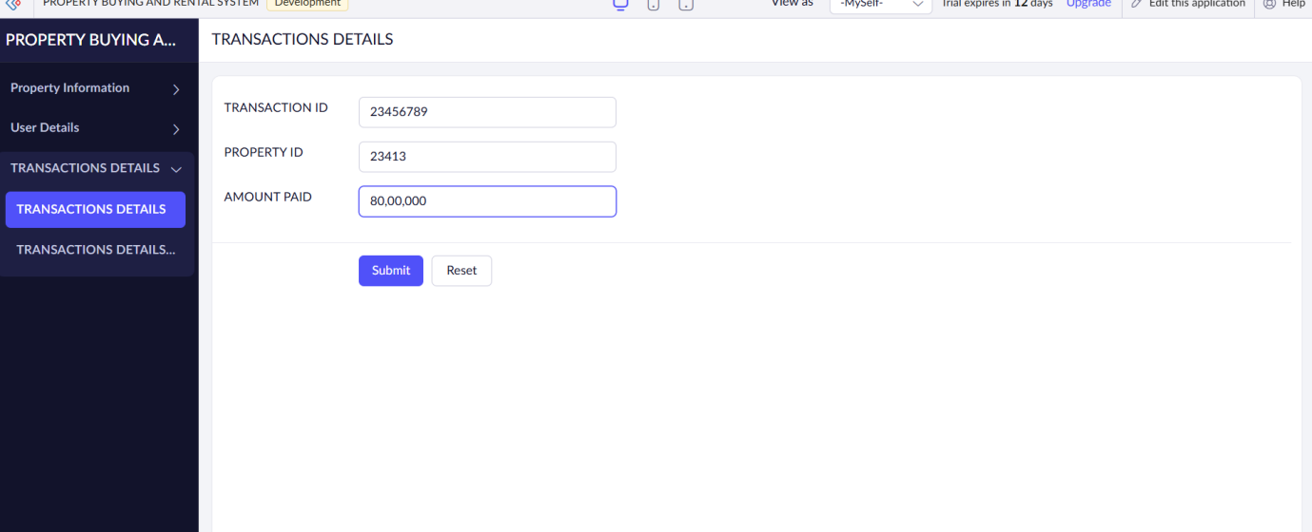

STEP6:THE SOFTWARE HAS BEEN CREATED.
